**1. Code and graph for circle :**

1. *//center of the circle*

a=0;

b=0;

2. *//radius of the circle*

r=2;

3. *//dummy variable for angle in range [0, 2*%pi]*

theta=linspace(0,2*%pi,100);

4. (a) *//x axis*

x=a+r*cos(theta);

(b) *//y axis*

y=b+r*sin(theta);

5. *//plot the circle*

plot(x,y);

Graph:

[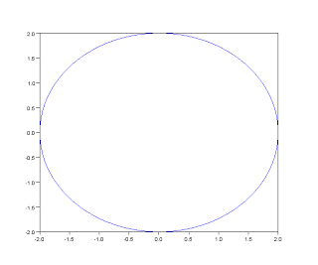](http://4.bp.blogspot.com/-7pafEV9li_8/UdGdEAoL3qI/AAAAAAAAAmc/VsYnLUxZcgU/s610/circle.png)

**2. Code and graph for parabola :**

Parabola y , -2<x<2.

1. *//This divides the interval (-2,2) in 100 equal parts*

x=linspace(-2,2,100);

2. //*Write the equation of parabola*

y=x^2;

3. *//Plot y as a function of x.*

plot(x,y)

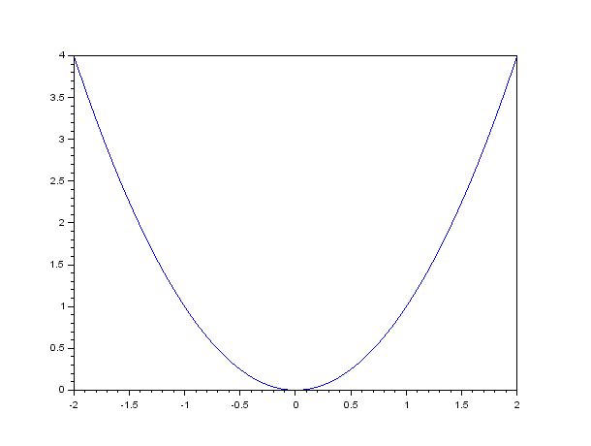

**3. Code and graph for Ellipse :**

**Ellipse : **

1. a=5;*//horizontal radius*

b=10;*//vertical radius*

2. x0=0;*//x0,y0 ellipse centre coordinates*

y0=0;

3. t=-%pi:0.01:%pi;

4. x=x0+a*cos(t);

y=y0+b*sin(t);

5.plot(x,y)

**Graph:**

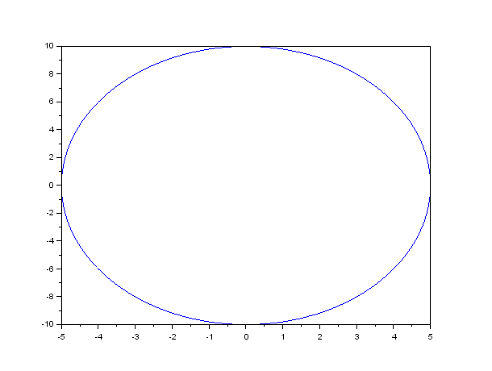

**3. Code and graph for Hyperbola :**

**Ellipse : **

Here

a=4, b=5; then

1. function**f**=hyperbola(**x**, **y**);

**f**=(**x**^2/16)-(**y**^2/25);

endfunction

1. xdata=linspace(-10,10,1000);
2. ydata=linspace(-10,10,1000);
3. contour(xdata,ydata,hyperbola,1)

The result of this code is the following picture.

